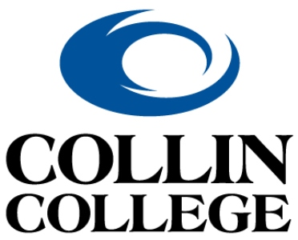 | Technical Campus  Architecture & Construction Programs

Instructor Recommendation Form
This student has applied for admission to Collin College’s Bachelor of Applied Science (BAS) in Construction Management program for the Fall 2026 term. To assist us in selecting the best qualified candidates for this program, we are asking you to answer the following questions to the best of your ability. Thank you in advance!

Student Name: ___________________________________________________________________________

- How would you rate this student’s collaborative skills?
☐ Always collaborates, often takes leadership role (4 pts.)
☐ Willingly collaborates (3 pts.)
☐ Somewhat collaborative in class (2 pts.)
☐ Generally does not contribute (0 pts.)

- How would you rate this student's participation in class?
☐ Participates in every class; responsive; engaged (4 pts.)
☐ Usually participates; generally responsive & engaged (3 pts.)
☐ Sometimes participates; not always responsive or engaged (2 pts.)
☐ Rarely participates. Often not responsive or engaged (0 pts.)

- How would you rate this student's level of responsibility (turning in work on time, giving full effort to work)
☐ Work always on time; good quality; good effort (4 pts.)
☐ Usually work is on time; almost always good quality and effort (3 pts.)
☐ More than half of the time work is on time and of good quality (2 pts.)
☐ Less than half the time work is on time and of good quality (1 pt.)
☐ Student appears to care very little for quality of work or due dates (0 pts.)

- Do you recommend this student for the BAS Program? If you cannot answer yes or not, please give the reason.
☐ Yes (3 pts.)
☐ No (0 pts.)
☐ Other: ____________________________________________________________________

Your name: _______________________________________________________________________________

Please return this completed form to the Construction Management Department at BASConstructionManagement@Collin.edu or drop off to Director Michael Zolton (C212) or Program Coach, Kate Smith (C211). Thanks!

