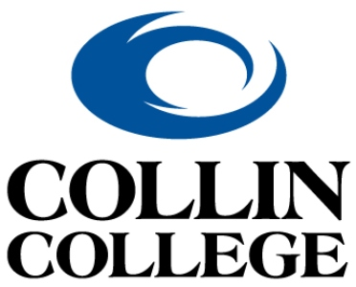 | Technical Campus  Architecture & Construction Programs

Employer Recommendation Form
______________________________________ has applied for admission to Collin College’s Bachelor of Applied Science (BAS) in Construction Management program for the Fall 2026 term. Admission to this program is selective and requires an additional application process. To assist us in selecting the best qualified candidates for this program, we are asking you to answer the following questions to the best of your ability. Thank you in advance for your support of our students and programs!
How long and in what capacity have you or did you work with the applicant? ____________________
__________________________________________________________________________________________
Please rate the applicant on the following attributes using the scale below:
1 = Strongly Disagree | 2 = Disagree | 3 = Neutral | 4 = Agree | 5 = Strongly Agree

- The applicant consistently demonstrates professionalism and reliability in the workplace.
☐ 1 ☐ 2 ☐ 3 ☐ 4 ☐ 5
- The applicant possesses strong communication skills and collaborates effectively with others.
☐ 1 ☐ 2 ☐ 3 ☐ 4 ☐ 5
- The applicant shows initiative and takes ownership of their responsibilities.
☐ 1 ☐ 2 ☐ 3 ☐ 4 ☐ 5
- The applicant adapts well to new challenges and demonstrates problem-solving abilities.
☐ 1 ☐ 2 ☐ 3 ☐ 4 ☐ 5
- I would confidently recommend this applicant for admission to the BAS Construction Management program.
☐ 1 ☐ 2 ☐ 3 ☐ 4 ☐ 5

The BAS Construction Management program is committed to developing the technical, leadership and project management skills essential to succeed in the construction industry. We try our best to schedule classes to minimize disruption to students’ work commitments. We ask that employers be flexible and supportive of their employees’ educational goals by accommodating their class schedules and giving them adequate time to complete their coursework. By accommodating their academic schedules and recognizing the value of this educational investment, you are not only contributing to our students’ success, but also helping to cultivate a highly skilled and knowledgeable future workforce. Thank you for your continued support of our program and students!

Your name and job title: ____________________________________________________________________
Company name: __________________________________________________________________________
Phone:________________________________________________________
Email:_________________________________________________________

Please return this completed form to the Construction Management Department at BASConstructionManagement@Collin.edu

Questions?
Contact Director Michael Zolton at mzolton@collin.edu or 972-553-1252 or Coach Kate Smith at cmsmith@collin.edu or 972-553-1246.

