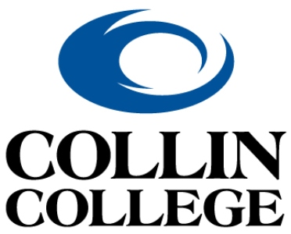 | Technical Campus  Architecture & Construction Programs

FALL 2026 APPLICATION FOR ADMISSION

Bachelor of Applied Science - Construction Management

Please read all information prior to beginning the application process. Carefully complete and submit with required documents. Any application that is incomplete or does not meet the eligibility requirements will not be processed.
All applicants must be in good academic standing with no disciplinary violations and a minimum overall GPA of 2.5 with a 3.0 GPA or higher in the construction management (i.e., CNBT/OSHT) classes to be considered for admission to this program. You must have completed or be in the process of completing an Associate of Applied Science (AAS) in Construction Management or a closely-related degree (i.e., Construction Science) by the end of the Summer 2026 term.
Before you complete this form:
- If you are not a current student, apply to Collin College at https://www.applytexas.org
- Submit copies of all official transcripts from prior colleges/universities, if applicable.

Applicant Information
Full Name: |  |  |  | Date:
 | Last | First | M.I.

Phone: |  | Email:

College-Wide ID (CWID):

Academic History
College attended:
From: |  |  | To: |  | Did you graduate? | YES | NO | Certificate/Degree:

Major: ____________________________
College attended:
From: |  |  | To: |  | Did you graduate? | YES | NO | Certificate/Degree:

Major: ____________________________

Employment History
Current Employer:
From: |  |  | To: |  | Job Title:

Previous Employer:
From: |  |  | To: |  | Job Title:

Military Service
Branch: |  | From: |  | To:

Rank at Discharge: |  | Type of Discharge:

If other than honorable, explain:

Essay Questions

Please submit your responses to these essay questions as an attachment to your completed application. Ensure that you address all components of each question thoroughly. Your responses should be a total of 1-2 typewritten pages, double-spaced (please do not exceed 2 pages). Make sure you put all the answers in your own words. We run all applications through a plagiarism and AI checker, so do not use AI to develop your answers.

- Describe your motivation for pursuing a degree in Construction Management. What experiences, interests, or goals have led you to choose this field, and how do you envision your future career contributing to the construction industry?

- Construction projects require strong leadership and effective teamwork. Share an example of a time when you led or participated in a team to accomplish a complex task. What challenges did you face, and how did you overcome them?

Letters of Recommendation

You may submit up to two letters of recommendation to support your application; one from your employer and another from one of your construction management instructors. It is recommended that you seek a recommendation from your co-op instructor, if possible. Please see the website for links to these forms. You can send the link or print out the form for your employer and/or instructor. They should return the completed form via email to BASConstructionManagement@collin.edu or return it in a sealed envelope to Director Michael Zolton or Program Coach Kate Smith

*Note: Letters of Recommendation will be kept confidential and will be read only by the BAS Construction Management Admissions Review Board.

Acknowledgement and Signature

I am applying for admission to the BAS Construction Management program. Please initial each item below.

- I understand that withholding or giving false information on this application, or any documents submitted in support of this application, will make me ineligible for admission to the BAS Construction Management program.

- I have completed or am enrolled to complete an Associate of Applied Science in Construction Management by the end of the Summer 2026.

- I am in good academic standing with no disciplinary violations and a minimum GPA of 2.5.

- I understand that I will not have access to read or obtain copies of any Letters of Recommendation submitted in support of my application and said letters will not be made a part of my education record.

- I understand that I must receive a Letter of Acceptance from the department in order to enroll in upper-level Construction Management courses.

Signature: |  | Date:

